**TABU SEARCH FOR TSP**

**Name :** Shashank Sundi

**Roll Number :** 19IM10028

***Activity 1.2:*** Understand the effect on optimal solution of selecting different tabu length.

|  |  |  |  |  |  |
| --- | --- | --- | --- | --- | --- |
| nAction | 545 |  |  |  |  |
| Ratio | 0.2 | 0.4 | 0.6 | 0.8 | 1 |
|  |  |  |  |  |  |
| Tabu Length | 109 | 218 | 327 | 436 | 545 |
| Optimal Sol. | 424.8639 | 465.2439 | 460.4636 | 424.8639 | 424.671 |

We observe that as the tabu length increases , the optimal solution is low initially and then it suddenly rises and decreases .Hence optimal solution improves with increase in tabu length. Moreover , optimal solution saturation is reached in earlier iterations for higher TL , as compared to smaller TL.

***Activity 1.4:*** Write a code for reversion strategy and use it in place of swap. Check whether it has improved solution.

Best Solution with Swap = 413.73

Best Solution with Reversion =400.1048

So, with reversion strategy the optima found is better.

***Activity 1.5:*** Write a code for insertion strategy and use it in place of swap. Check whether it has improved solution.

Best Solution with Swap = 413.73

Best Solution with Insertion Strategy = 390.6841

So, with Insertion Strategy the optima found is better.

***Activity 1.6:*** In the function file DoAction.m write a switch statement and make 3 cases swap, insertion and reversion. Check whether it has improved solution.

The optimal solution found after making the changes in DoAction is 390.6841 , same as that found with Insertion Strategy.

Position: [15 1 7 18 14 6 11 16 3 8 5 17 9 4 12 10 2 13]

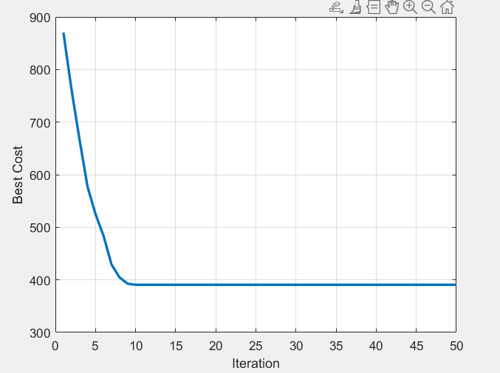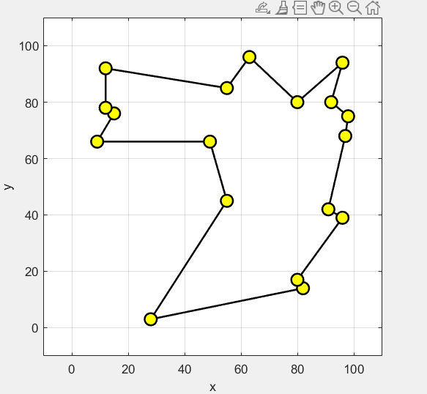

***Activity 2:***  Solve the following symmetric TSP problem using tabu search method **[Code submission required]**

|  |  |  |  |  |  |
| --- | --- | --- | --- | --- | --- |
|  | C1 | C2 | C3 | C4 | C5 |
| C1 | 0 | 132 | 217 | 164 | 158 |
| C2 |  | 0 | 290 | 201 | 79 |
| C3 |  |  | 0 | 113 | 303 |
| C4 |  |  |  | 0 | 196 |
| C5 |  |  |  |  | 0 |

**Path – 1-2-5-4-3**

**Best Sol - 520**